Mount Litera Zee School, Haridwar
Syllabus Term-II (2016-17)
Class-VII
SA 2
Subject | Syllabus
ENGLISH | Gulmohar- L-9: Everest Reaction, L-11: Zero Hour, L-12: The Play.  Poem- Break, Break, Break, Wandering singers, Lobster Quadrille  Grammar- L-13, 14, 15, 16, 17, 18, 19, 20, 21.  Writing- Diary writing, Paragraph writing, Condolence letter, Imaginative writing Formal letter writing.
HINDI | 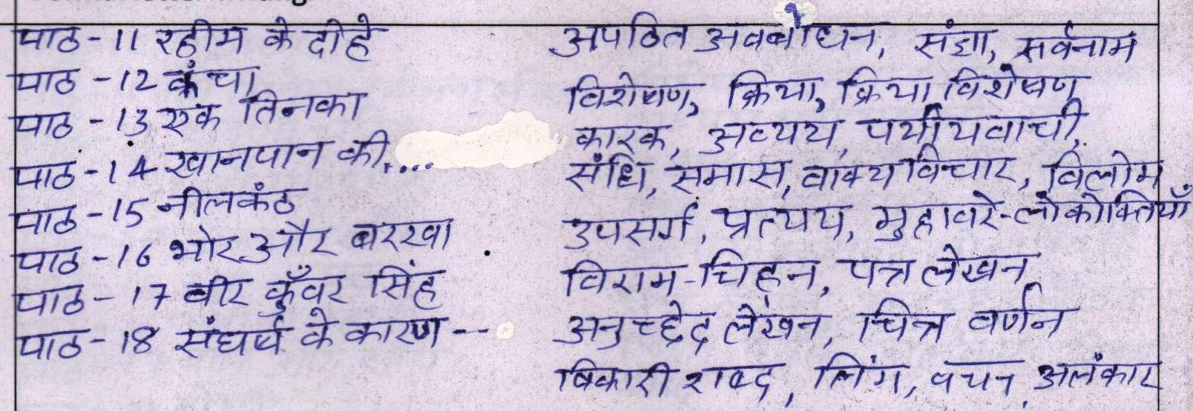
Maths | Exponents and power , Practical Geomatry, Algebraic Exressions , Data Handling , Perimeter and Area , Visualising Solid shapes.
SCIENCE | L-5 Acids,Bases and Salts , L-8 Soil , L-9 Respiration in organisms , L-10 Transport of substances in Animals and Plants, L-11 Reproduction in Plants , L-15 Light ,L-17 Forest our lifeline
S.ST | Ch- 9, Religious movement, ch - 10 Flowering of religional cultures,ch -11, new kingdoms: a saga of growth and declinech-19 water - fresh and saline,ch - 20 ocean water and its circulation, ch 21 - natural vegetation and wildlife, ch 22, The Human Environment - settlements ch - 23 Transport and Communication, ch - 24, life in desert regions, ch- 25 life in tropical and sub tropical regions,ch 34 role played by gender, ch - 35, unpacking gender, ch 36 - market around us.ch 37, a wholesale market.
SANSKRIT | 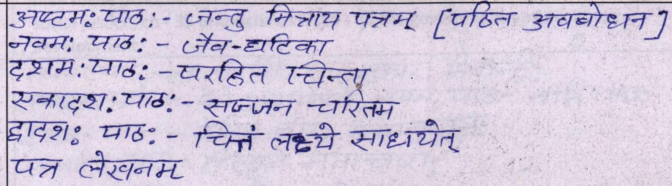
COMPUTERS | Ch-7 Elementary HTML-I , Ch-8 Elementary HTML-II , Ch-9 Creating Forms in HTML , Ch-10 Frames in HTML , Ch- 11 JavaScript in HTML Documents , Ch-14 Introduction to C++
G.K | Unit - 4 - The world of nature, unit - 5 Sports and games unit - 6 Art and culture,Current affairs

